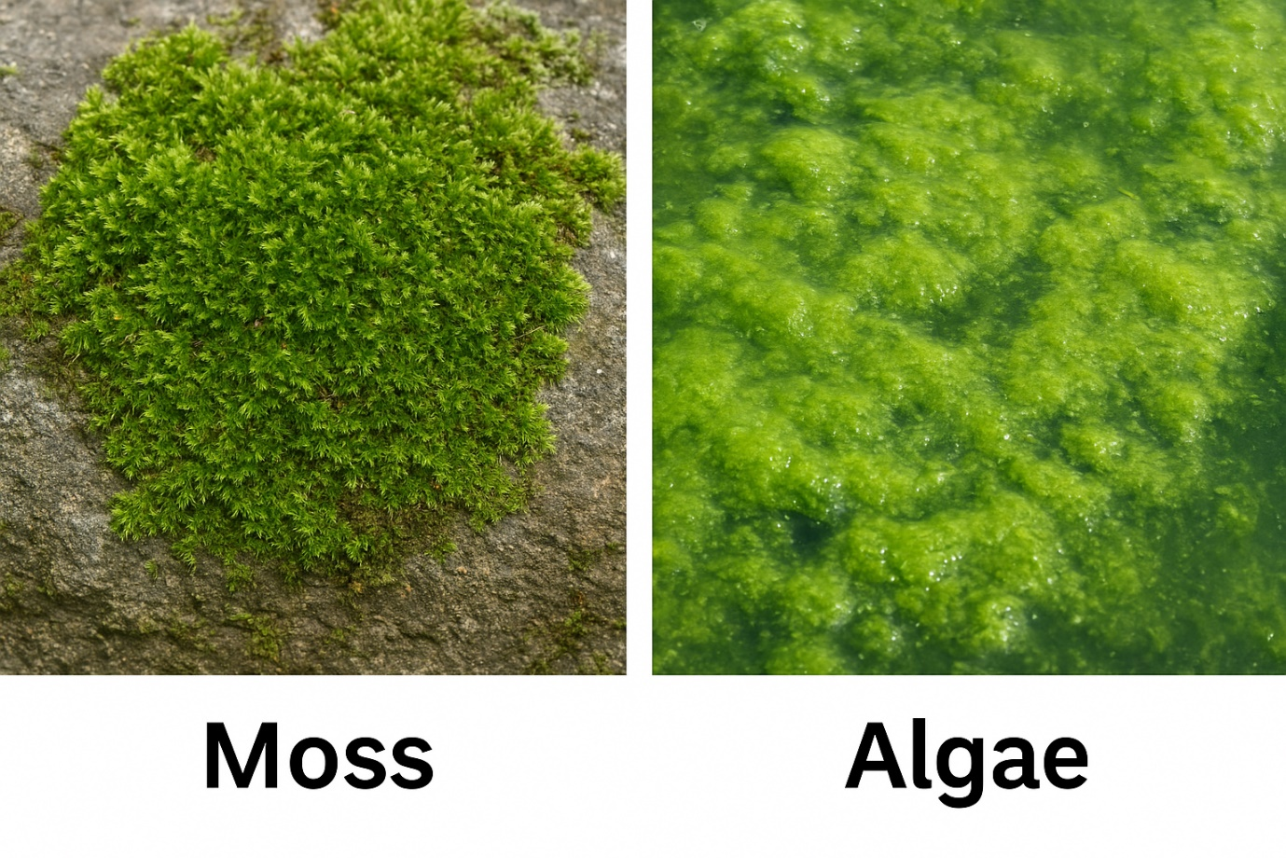No, algae are not a type of moss; they belong to different kingdoms and have distinct structures. While both are simple, photosynthetic, non-vascular organisms, algae are typically classified under the kingdom Protista and lack true stems, leaves, or roots, whereas mosses are in the kingdom Plantae and have simple stem-like and leaf-like structures and rhizoids for anchorage.
Feature | Algae | Moss
Kingdom | Protista | Plantae
Structure | Thallus-like, undifferentiated body lacking specialized tissues, stems, leaves, or true roots | Simple stem-like and leaf-like structures and rhizoids for anchorage and water absorption
Habitat | Primarily aquatic (marine and freshwater), but can be terrestrial in wet areas | Primarily terrestrial, but can be aquatic
Complexity | Some can be unicellular, while others are multicellular | Always multicellular
'काई' का अर्थ पानी में उगने वाली एक प्रकार की महीन वनस्पति या काई (Moss) से है, जो गीली और छायादार जगहों पर जम जाती है। इसका उपयोग समुद्र या महासागर के संदर्भ में भी किया जाता है, जैसे समुद्री शैवाल (seaweed)। काई एक गैर-संवहनी पौधा है और इसकी कई किस्में होती हैं, जैसे समुद्री काई और जल काई।
Aapka doubt bilkul sahi hai — algae (शैवाल) aur moss (काई) dekhne me kuch cases me similar lag सकते हैं, lekin dono bilkul अलग समूह hain.
Chaliye simple language me clear difference samajhte hain:

✅ Why do algae & moss look similar?
➡️ Because dono hara rang (chlorophyll) rakhte hain
➡️ Dono zamin par ya gile sathano par green patches jaisa dikh sakte hain
BUT… dono ki body structure, habitat, aur biology bilkul alag hai.

🌱 Clear Difference (Very Simple Way)

1. Moss (काई) = Simple Land Plant
✔ धरती पर उगते हैं (moist जगहों में)
✔ इन्होंने leaf-like, stem-like structure hoti hai
✔ Par ye vascular plant nahi (veins nahi hoti)
✔ True plants category me aate hain
👉 Aap moss ko deewar, pathar, ped ke tale, wet soil par dekhte ho.

2. Algae (शैवाल) = Water Organism
✔ पानी में उगते हैं (तालाब, नदी, समुद्र)
✔ Body thallus होती है → jisme
✖ जड़ नहीं
✖ तना नहीं
✖ leaves नहीं
✔ कई algae microscopic होते हैं ( aankh se nahi dekhte )
✔ True plants नहीं माने जाते (protist group)
👉 Aap algae ko talabon me green layer jaisa dekhte ho.

🖼 Visual Difference (Simple Mental Image)

Moss (काई)
- chhota sa “soft carpet” jaisa
- structure leafy lagta hai
- dry land par bhi milta hai (lekin moist ho)

Algae (शैवाल)
- slimy green layer
- mostly water surface par
- leaves/tana kuch nahi

⭐ Why they are NOT same?
Feature | Moss (काई) | Algae (शैवाल)
Organism type | Land plant | Protist
Roots? | No true roots, but rhizoids | No roots
Leaves? | Yes, leaf-like structures | No leaves
Habitat | Moist land | Water
Size | Visible green plant | Microscopic → big seaweed

If you want, I can generate realistic images or side-by-side photo comparison (not cartoon style).
Just say “real images dono ki de do”.
Top of Form

Bottom of Form
ChatGPT can make m
Yes, moss is a plant, belonging to the group of non-vascular plants called bryophytes. Mosses are small, flowerless plants that typically grow in damp, shady areas and reproduce through spores, not seeds. They lack true roots, stems, and leaves, but have root-like structures called rhizoids, and can be very important for ecosystems.
- Classification: Mosses are classified under the division Bryophyta within the plant kingdom, making them definitively a type of plant.
- Characteristics: They are known as non-vascular plants, meaning they don't have a system of tubes (xylem and phloem) to transport water and nutrients, so they absorb water and minerals directly from their surroundings.
- Structure: They have a simple body with structures that are "root-like" (rhizoids), "stem-like," and "leaf-like," though they are not true roots, stems, or leaves.
- Reproduction: Mosses reproduce using spores, and do not produce flowers or seeds.
- Habitat: They are most commonly found in damp, shady locations, such as forest floors or riverbanks, though they can be found worldwide in various habitats.
- Mosses are an example of which among the following division ...
23 Apr 2020 — 4.6. Mosses are an example of Bryophytes. Mosses are non-vascular plants (not transporting water and minerals within) a...

Testbook
- Moss Plant: Structure, Life Cycle & Importance for NEET, CBSE
24 Aug 2025 — Meet the Moss Family: Who Are They? Mosses are tiny, soft, green plants that belong to a group called Bryophyta. Their ...

Vedantu
- Life Cycle of a Moss Plant - BYJU'S
6 Jun 2022 — Moss are small, non-vascular flowerless plant species found growing in shady and damp areas. These plant species lack va...

BYJU'S

Show all
Q1

How is algae different than moss?
Algae are marine organisms which belong to the kingdom Protista, whereas mosses are terrestrial organisms which belong to the kingdom Plantae.
Q2

Is moss a fungus or algae?
A moss is neither a fungus, nor an algae. Rather, it is a plant under the division of Bryophyta in the kingdom of Plantae.
Q3

What is the difference between fungi and moss?
Mosses are plants, whereas fungi are neither plants nor animals. The major difference between a fungi and moss is that fungi cannot make their own food, while mosses can.
Q4

What makes mosses different?
Mosses are non-flowering plants and they lack roots. Instead they have hair-like structures called rhizoids, which anchor them to the soil.


